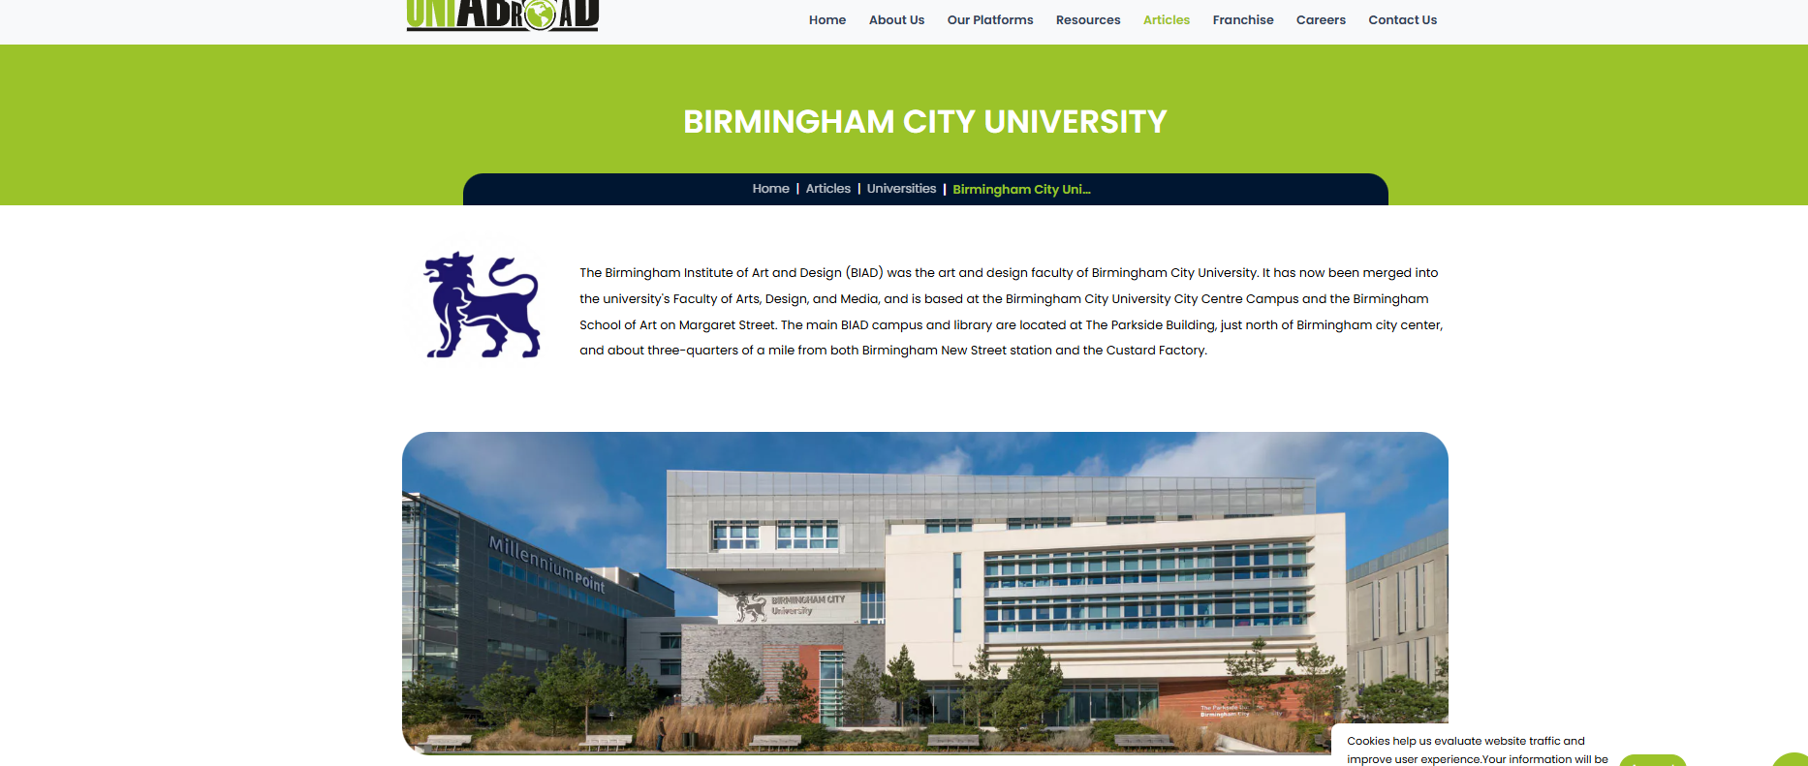

<!DOCTYPE html>

<html lang="en">

<head>

<meta charset="UTF-8">

<meta name="viewport" content="width=device-width, initial-scale=1.0">

<link rel="stylesheet" href="styles.css">

<title>Birmingham City University</title>

</head>

<body>

<header>

<div class="logo">

<img src="path_to_your_logo.png" alt="University Logo">

</div>

<nav>

<ul>

<li><a href="#">Home</a></li>

<li><a href="#">About Us</a></li>

<li><a href="#">Our Platforms</a></li>

<li><a href="#">Articles</a></li>

<li><a href="#">Franchise</a></li>

<li><a href="#">Careers</a></li>

<li><a href="#">Contact Us</a></li>

</ul>

</nav>

</header>

<main>

<h1>BIRMINGHAM CITY UNIVERSITY</h1>

<p>

The Birmingham Institute of Art and Design (BIAD) was the art and design faculty of Birmingham City University. It has now been merged into the university's Faculty of Arts, Design, and Media, and is based at the Birmingham City University City Centre Campus and the Birmingham School of Art on Margaret Street.

</p>

<img src="path_to_your_image.jpg" alt="Millennium Point" class="university-image">

</main>

<footer>

<p>Cookies help us evaluate website traffic and improve user experience. For more information, please read our privacy policy.</p>

</footer>

<script src="script.js"></script>

</body>

</html>

body {

font-family: Arial, sans-serif;

margin: 0;

padding: 0;

background-color: #f4f4f4;

}

header {

background-color: #3b8c27;

color: white;

padding: 10px 20px;

display: flex;

justify-content: space-between;

align-items: center;

}

.logo img {

height: 50px;

}

nav ul {

list-style: none;

padding: 0;

}

nav ul li {

display: inline;

margin: 0 15px;

}

nav ul li a {

color: white;

text-decoration: none;

}

h1 {

color: #3b8c27;

margin-top: 20px;

}

.university-image {

width: 100%;

height: auto;

max-width: 900px;

margin-top: 20px;

}

footer {

background-color: #3b8c27;

color: white;

text-align: center;

padding: 15px 0;

margin-top: 20px;

}

// Placeholder for future scripts

document.addEventListener("DOMContentLoaded", function() {

console.log("Document is ready");

});



Footer

<!DOCTYPE html>

<html lang="en">

<head>

<meta charset="UTF-8">

<meta name="viewport" content="width=device-width, initial-scale=1.0">

<link rel="stylesheet" href="styles.css">

<title>BCU University Footer</title>

</head>

<body>

<footer>

<div class="footer-container">

<div class="logo">

<img src="bcu-logo.png" alt="BCU University Logo">

</div>

<div class="exclusive-platforms">

<h3>Contact</h3>

<p>Email: info@bcu.ac.uk</p>

<p>Phone: +44 121 331 5000</p>

</div>

<div class="resources">

<h3>Resources</h3>

<ul>

<li>Student Recruitment</li>

<li>Scholarships</li>

<li>Accommodation</li>

</ul>

</div>

<div class="headquarters">

<h3>Headquarters</h3>

<p>BCU University</p>

<p>Cardonald Campus, 370 Crookston Rd,</p>

<p>Glasgow G53 7LL, United Kingdom</p>

</div>

<div class="corporate-office">

<h3>Corporate Office (India)</h3>

<p>BCU Technology Ltd.</p>

<p>No. 165, Opp. Brahmastan Kalyana Mantapa,</p>

<p>Sahukar Channiah Road, TK Layout,</p>

<p>Mysuru, Karnataka, India</p>

</div>

</div>

<div class="footer-bottom">

<p>Need Help? Talk to us <a href="#">REGISTER NOW</a></p>

<p>Privacy Policy | Terms & Conditions | Disclaimer | Refund Policy</p>

<p>&copy; 2023 BCU University. All rights reserved.</p>

</div>

</footer>

</body>

</html>

body {

font-family: Arial, sans-serif;

margin: 0;

padding: 0;

background-color: #f5f5f5;

}

footer {

background-color: #1a1a1a;

color: white;

padding: 20px 0;

}

.footer-container {

display: flex;

justify-content: space-around;

flex-wrap: wrap;

}

.logo img {

max-width: 150px;

}

h3 {

color: #4CAF50;

}

ul {

list-style-type: none;

padding: 0;

}

ul li {

margin: 5px 0;

}

.footer-bottom {

text-align: center;

margin-top: 20px;

background-color: #0d0d0d;

padding: 10px;

}

.footer-bottom p {

margin: 5px 0;

}

.footer-bottom a {

color: #4CAF50;

text-decoration: none;

}

.footer-bottom a:hover {

text-decoration: underline;

}

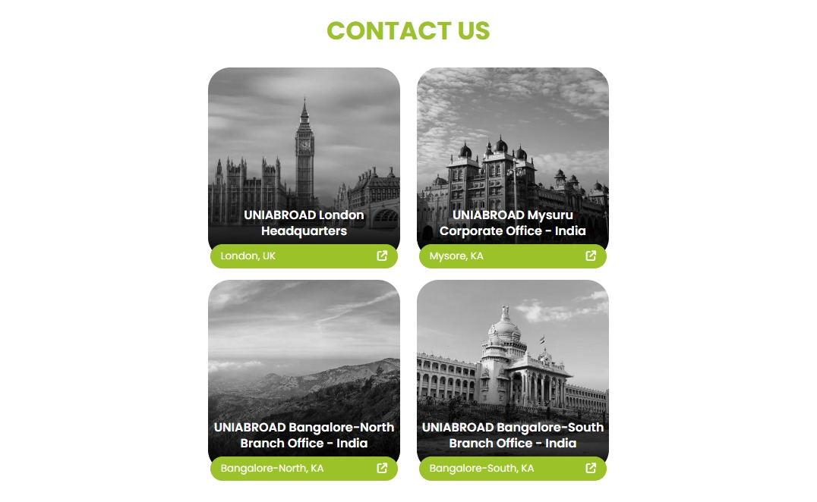

<!DOCTYPE html>

<html lang="en">

<head>

<meta charset="UTF-8">

<meta name="viewport" content="width=device-width, initial-scale=1.0">

<title>Contact Us - BCU University</title>

<link rel="stylesheet" href="styles.css">

</head>

<body>

<div class="container">

<h1>Contact Us</h1>

<div class="locations">

<div class="location-card">

<img src="london.jpg" alt="UNIAABROAD London Headquarters">

<h3>UNIAABROAD London Headquarters</h3>

<p>London, UK</p>

</div>

<div class="location-card">

<img src="mysore.jpg" alt="UNIAABROAD Mysuru Corporate Office - India">

<h3>UNIAABROAD Mysuru Corporate Office - India</h3>

<p>Mysore, KA</p>

</div>

<div class="location-card">

<img src="bangalore-north.jpg" alt="UNIAABROAD Bangalore-North Branch Office - India">

<h3>UNIAABROAD Bangalore-North Branch Office - India</h3>

<p>Bangalore-North, KA</p>

</div>

<div class="location-card">

<img src="bangalore-south.jpg" alt="UNIAABROAD Bangalore-South Branch Office - India">

<h3>UNIAABROAD Bangalore-South Branch Office - India</h3>

<p>Bangalore-South, KA</p>

</div>

</div>

<form class="contact-form">

<h2>Get in Touch</h2>

<label for="name">Name:</label>

<input type="text" id="name" name="name" required>

<label for="email">Email:</label>

<input type="email" id="email" name="email" required>

<label for="message">Message:</label>

<textarea id="message" name="message" required></textarea>

<button type="submit">Submit</button>

</form>

</div>

</body>

</html>

body {

font-family: Arial, sans-serif;

background-color: #f8f9fa;

margin: 0;

padding: 20px;

}

.container {

max-width: 1200px;

margin: auto;

text-align: center;

}

h1 {

color: #4CAF50;

}

.locations {

display: flex;

flex-wrap: wrap;

justify-content: space-around;

margin: 20px 0;

}

.location-card {

width: 200px;

margin: 15px;

border-radius: 10px;

overflow: hidden;

box-shadow: 0 2px 5px rgba(0,0,0,0.1);

transition: transform 0.2s;

}

.location-card img {

width: 100%;

filter: grayscale(100%);

transition: filter 0.3s;

}

.location-card img:hover {

filter: grayscale(0%);

}

.location-card h3 {

font-size: 18px;

margin: 10px 0;

}

.location-card p {

color: #777;

}

.contact-form {

background-color: #fff;

padding: 20px;

border-radius: 10px;

box-shadow: 0 2px 5px rgba(0,0,0,0.1);

margin-top: 20px;

}

.contact-form h2 {

margin-bottom: 15px;

}

.contact-form label {

display: block;

margin: 10px 0 5px;

}

.contact-form input,

.contact-form textarea {

width: 100%;

padding: 10px;

border: 1px solid #ccc;

border-radius: 5px;

}

.contact-form button {

background-color: #4CAF50;

color: white;

padding: 10px;

border: none;

border-radius: 5px;

cursor: pointer;

margin-top: 10px;

}

.contact-form button:hover {

background-color: #45a049;

}

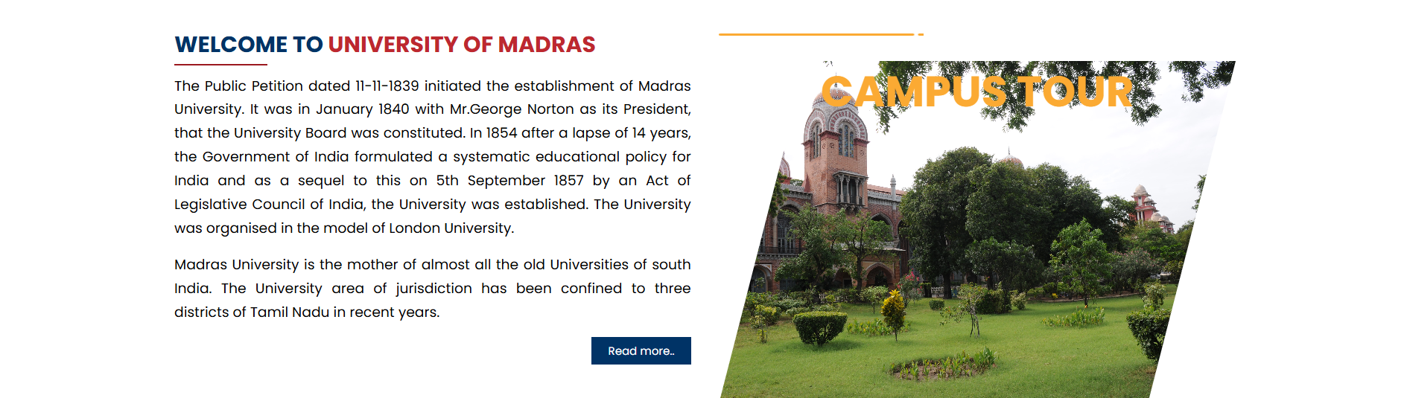

<!DOCTYPE html>

<html lang="en">

<head>

<meta charset="UTF-8">

<meta name="viewport" content="width=device-width, initial-scale=1.0">

<title>Birmingham City University</title>

<link rel="stylesheet" href="styles.css">

</head>

<body>

<div class="container">

<header>

<h1>Welcome to Birmingham City University</h1>

</header>

<main>

<p>

Birmingham City University is known for its commitment to providing a diverse range of high-quality education

designed to meet the needs of students and employers alike. Established in 1992, it has a history of

education dating back to 1843. Today, the university offers a broad portfolio of courses across various disciplines,

including art, design, and technology.

</p>

</main>

<footer>

<h2>CAMPUS TOUR</h2>

<button class="read-more">Read more...</button>

</footer>

</div>

</body>

</html>

body {

font-family: Arial, sans-serif;

background-color: #f4f4f4;

margin: 0;

padding: 0;

}

.container {

max-width: 1200px;

margin: auto;

padding: 20px;

background-color: white;

box-shadow: 0 0 10px rgba(0, 0, 0, 0.1);

}

header {

text-align: center;

border-bottom: 2px solid #0072B1;

padding-bottom: 10px;

}

h1 {

color: #D80027;

}

h2 {

color: #FFA500;

}

main {

margin: 20px 0;

}

footer {

display: flex;

justify-content: space-between;

align-items: center;

margin-top: 20px;

}

.read-more {

background-color: #0072B1;

color: white;

border: none;

padding: 10px 20px;

border-radius: 5px;

cursor: pointer;

}

.read-more:hover {

background-color: #005f8b;

}

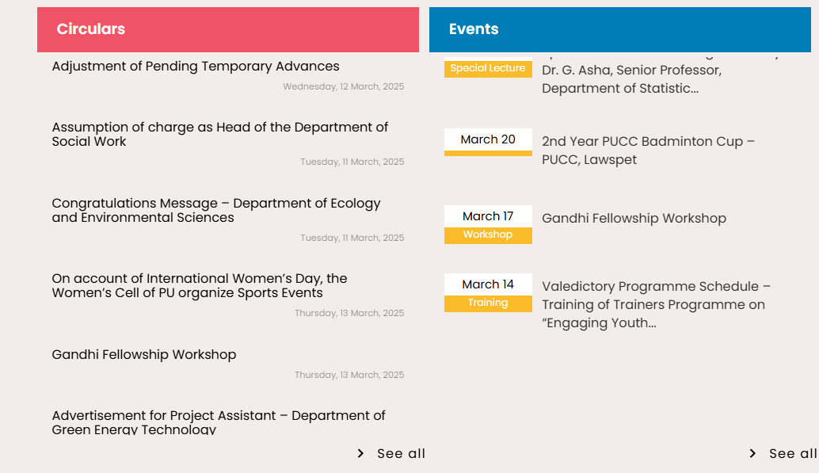

<!DOCTYPE html>

<html lang="en">

<head>

<meta charset="UTF-8">

<meta name="viewport" content="width=device-width, initial-scale=1.0">

<title>Sliding Circulars and Events</title>

<link rel="stylesheet" href="styles.css">

</head>

<body>

<div class="container">

<div class="circulars">

<h2 class="header">Circulars</h2>

<div class="items">

<div class="item">Adjustment of Pending Temporary Advances <br> <small>Wednesday, 12 March, 2025</small></div>

<div class="item">Assumption of charge as Head of the Department of Social Work <br> <small>Tuesday, 11 March, 2025</small></div>

<div class="item">Congratulations Message – Department of Ecology and Environmental Sciences <br> <small>Tuesday, 11 March, 2025</small></div>

<div class="item">On account of International Women’s Day, the Women’s Cell of PU organize Sports Events <br> <small>Thursday, 13 March, 2025</small></div>

<div class="item">Gandhi Fellowship Workshop <br> <small>Thursday, 13 March, 2025</small></div>

</div>

</div>

<div class="events">

<h2 class="header">Events</h2>

<div class="items">

<div class="item">Special Lecture <br> Dr. G. Asha, Senior Professor, Department of Statistics... </div>

<div class="item">March 20 <br> 2nd Year PUCC Badminton Cup – PUCC, Lawspet</div>

<div class="item">March 17 <br> Gandhi Fellowship Workshop</div>

<div class="item">March 14 <br> Valedictory Programme Schedule – Training of Trainers Programme on “Engaging Youth…”</div>

</div>

</div>

</div>

<script src="script.js"></script>

</body>

</html>

body {

font-family: Arial, sans-serif;

background-color: #f4f4f4;

margin: 0;

padding: 20px;

}

.container {

display: flex;

justify-content: space-between;

}

.circulars, .events {

width: 45%;

background: white;

border-radius: 8px;

padding: 20px;

box-shadow: 0 2px 10px rgba(0, 0, 0, 0.1);

transition: transform 0.5s ease;

}

.header {

background-color: #ff4d4d; /* Red Header */

color: white;

padding: 10px;

border-radius: 5px;

text-align: center;

}

.items {

display: flex;

flex-direction: column;

}

.item {

padding: 15px;

border-bottom: 1px solid #e0e0e0;

}

.item:last-child {

border-bottom: none;

}

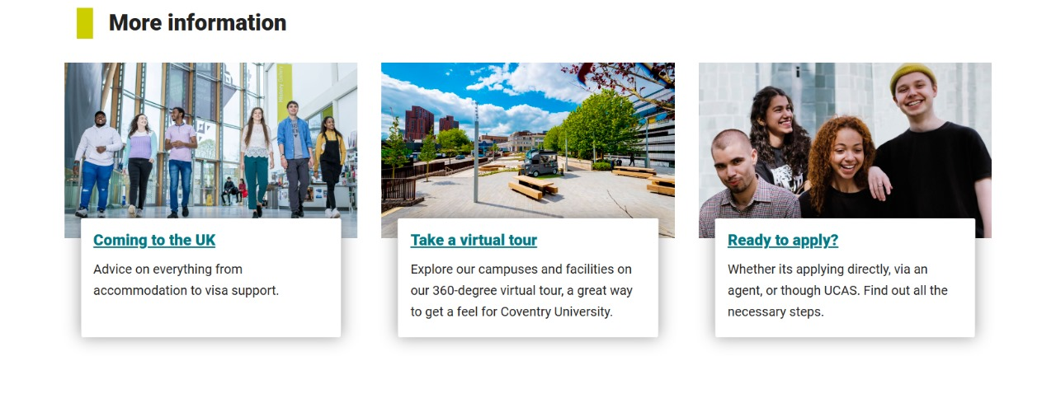

<!DOCTYPE html>

<html lang="en">

<head>

<meta charset="UTF-8">

<meta name="viewport" content="width=device-width, initial-scale=1.0">

<link rel="stylesheet" href="styles.css">

<title>Birmingham City University Events</title>

<style>

body {

font-family: Arial, sans-serif;

margin: 0;

padding: 20px;

background-color: #f4f4f4;

}

.container {

display: flex;

justify-content: space-around;

flex-wrap: wrap;

}

.card {

background-color: white;

border-radius: 5px;

box-shadow: 0 2px 10px rgba(0, 0, 0, 0.1);

width: 30%;

margin: 10px;

padding: 20px;

text-align: center;

}

.card h3 {

color: #005EB8; /* BCU color */

}

</style>

</head>

<body>

<h1>More Information on BCU Events</h1>

<div class="container">

<div class="card">

<h3>Upcoming Events</h3>

<p>Stay updated with our calendar of events including guest lectures, workshops, and networking opportunities.</p>

</div>

<div class="card">

<h3>Virtual Open Days</h3>

<p>Join our virtual open days to experience what it's like to study at BCU from the comfort of your home.</p>

</div>

<div class="card">

<h3>Student Societies</h3>

<p>Get involved with various student societies–from cultural to academic–meet new friends and expand your horizons!</p>

</div>

</div>

</body>

</html>